A000-Asia-China-Hongshan-Cong-Jade-2 Tier

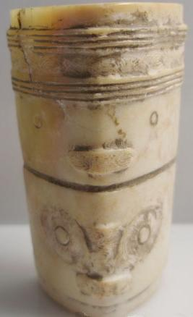

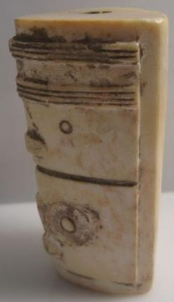 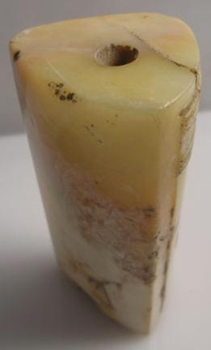 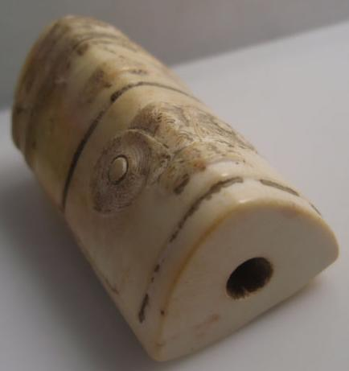

NK5750.2.A1

H: 5.8 cm. x W: 3.4 cm.

Material: Jade

Case No.: 5

Accession Number:

Formal Label:

**Display Description:**

**Hongshan culture** ([紅山文化](https://en.wiktionary.org/wiki/紅山文化); [pinyin](https://en.wikipedia.org/wiki/Pinyin): [*Hóngshān wénhuà*](https://en.wiktionary.org/wiki/Hóngshān_wénhuà)) is a [Neolithic](https://en.wikipedia.org/wiki/Neolithic) culture in the [Liao](https://en.wikipedia.org/wiki/Liao_river) river basin from [Inner Mongolia](https://en.wikipedia.org/wiki/Inner_Mongolia) to [Liaoning](https://en.wikipedia.org/wiki/Liaoning), and dated to 4700-2900 BCE. This Hongshan jade cong has two different masks, the top one depicting a deceased ancestor and the bottom one depicting the protective dragon. While it is diminutive in size this feature distinguishes it as being significant.

LC Classification:

Date or Time Horizon:

Geographical Area:

Map:

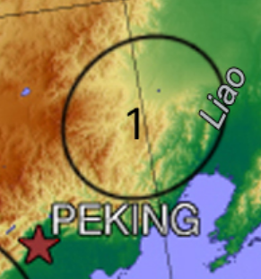 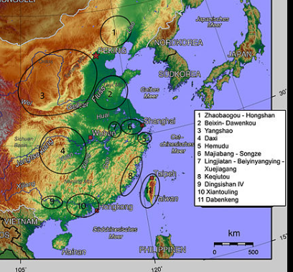

Hongshan in the Liao region and Chinese Neolithic cultures after map built with the help of Li Liu and Xingcan Chen : *The Archaeology of China : From the Late Paleolithic to the Early Bronze Age*, Cambridge University Press 2012, page 170. Compared to : Li Feng *Early China*, 2013. Page 19 : The "Chinese Interaction Spheres" map. After [CC BY-SA 4.0](https://creativecommons.org/licenses/by-sa/4.0)

GPS Coordinates:

Cultural Affiliation:

Medium:

**Dimensions**:   
**Weight:**

**Provenance**:

**Condition:**

**Discussion:**

**References:**

